Vacation Without Worry

Here’s Your Home Security Checklist
Serving Indiana since 2008 5 minute read 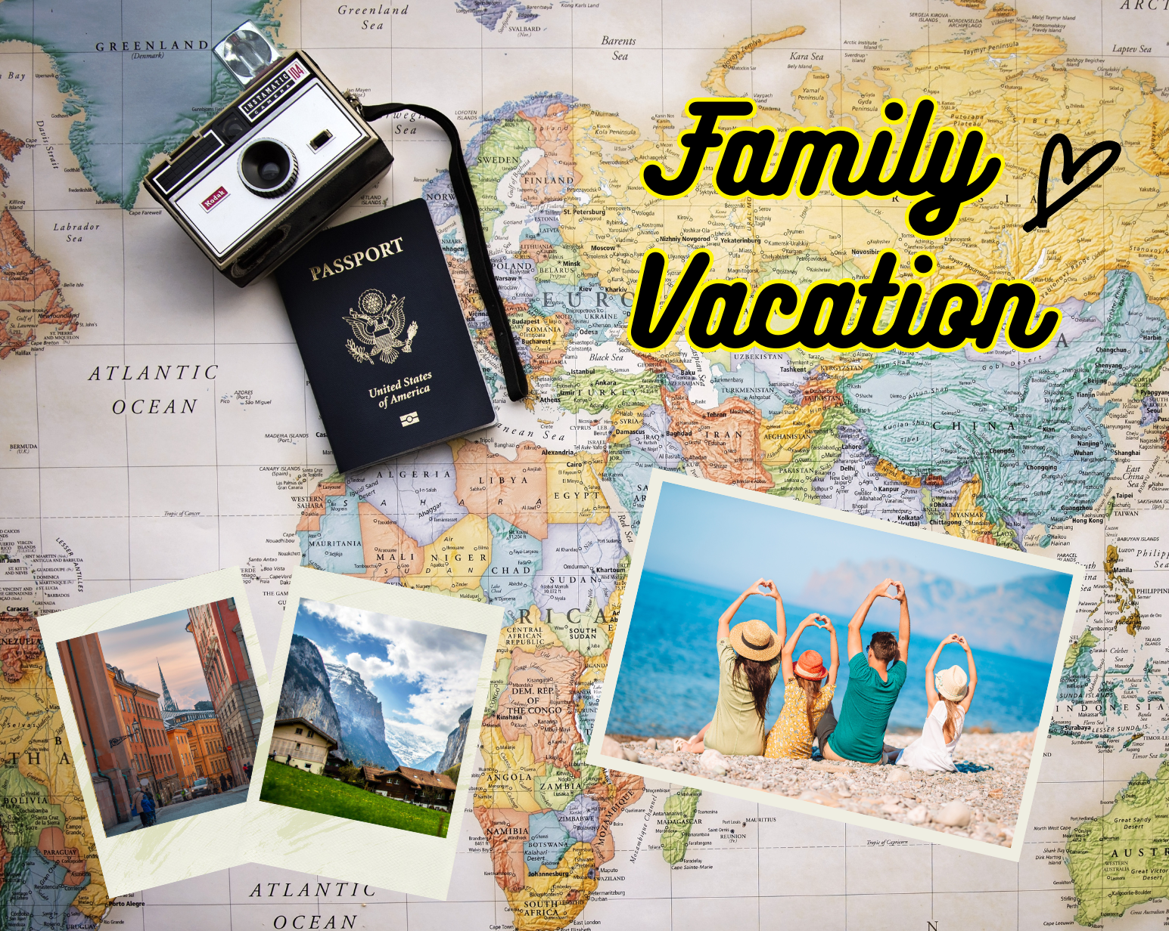
Ahhh yes…the moment you’ve been waiting for. Sand in your toes and surf in your hair. Or maybe you’re just looking forward to silence and a majestic mountain view during your morning cup of coffee. Whatever your vacation plans, one thing is certain….

You want to relax.

Below are some best practices to follow that will give you peace of mind during your getaway.

*Download or print out this sheet, and check off each section before you leave the house to be sure everything is airtight and good to go.

Basic Safety:
We all know the drill:
- Hold the mail at the post office or have someone pick it up.
- Make sure no packages are to be delivered (Amazon or otherwise).
- Have a house-sitter or friend/family member visit the home throughout your absence.
- Hire a neighbor kid (or service) to mow the lawn.
- Set your indoor and outdoor lights on a timer.

Digital Safety:
Protect yourself from online intruders:
- DO NOT set your email/profile to “away” or “offline.”
It is not hard to discover an email address. Receiving an automated message to a simple email may not seem like a giveaway, but that paired with no movement online can give tech-savvy thieves the gumption to act. Many companies have email policies for the office, so if you’re required to notify of your absence, simply state just that. Do not give any details. As far as personal email goes,it’s best just to leave it be.
- DO NOT announce your trip on social media.
You can share photos and stories when you return. Profiles may be set for “friends only” viewing, but there are always ways around it. And while most likely it wouldn’t be an issue, why take the chance? This includes check-ins, photo and video uploads, and any hint that you are not at home. If you have already posted such, erase them or make them private to only you.
- Change your passwords (never keep them in an unlocked file)
This is a good practice anyway, but if you will be offline for a while, be sure to update any passwords that guard sensitive information. And NEVER keep them in a written file somewhere in the house.
- BE SURE to bring charged power banks and cords for your phone.
You never know when you may need a hotspot to make an emergency call.

Practical Safety:
Simple, but often overlooked:
- Put away loose outdoor objects.
Ladders, chairs, tools, and even dead branches can be picked up and used to destroy property; even if it’s just the wind. It’s good sense to make sure you’re not offering up opportunities to damage your home. Not to mention how expensive ladders and tools can be if stolen.
- Clean out your car and clear your GPS.
Be sure your car is free from all pieces of mail, food, valuables and important documents. Personal info and valuables are easy prey for car burglars, but you also want to prevent mold (from old food and drink) eating away at your upholstery or just stinking up your car for when you return. If you are leaving your car at the airport, clear the GPS and hide it. A thief may very well use it to backtrack your last route and find your home. Theft occurs in cars 20.2% of the time, compared to in homes 5.8%. So, it is just as important to make sure you take every precaution to limit any theft that might occur.
- DO NOT hide a key.
No matter what grandma may have done in her day, it is simply no longer safe to leave keys, fobs, garage openers or codes hidden around your home. If you need to make sure someone can enter, use your smart door lock. You can set up a special code and then keep track each time someone goes in or out. This way you can lock and unlock it from your phone or set certain times or days of the week they can use it! Customize it however you want!
- Put a travel notice on your card.
Call your bank or credit union and let them know you’ll be out of town for a while (national or international). This will drastically cut down on any chance of fraud, while allowing you the freedom to spend where you need to, when you need to, without being flagged.
- Be sure you can log into your phone’s security app
This lets you remain in complete control no matter where you are! Use your cameras to peek in on your plants, if you let a friend in to water them. Make sure your outdoor cameras’ deterrent feature (which beeps and lights up to warn anyone approaching) is turned on and the settings are adjusted to alert you when they see a person, animal or maybe a ufo. 🛸
- Run a last check around the house before you leave.
If it’s winter time, leave the faucet dripping (a water bill is cheaper than replacing frozen pipes). Check your smoke detectors and flood sensors. Test your home security system to be sure it’s working properly. Double check that all doors, windows, and entryways are locked tightly. Have a surge protector in place for your electronics and a plan for power outages. Though a lot of this may be routine, in the excitement of leaving for vacation, it is easy to overlook or take for granted.
- Don’t go it alone.
Let your local alarm company know how long you’ll be gone. In the event of an emergency, it never hurts to make sure they know and have a clear plan for who they need to contact if the security system detects an emergency at your home. One of the best deterrents for a burglar is having (and advertising via a sign in your yard or stickers on your windows) an actively monitored alarm system. Simplx Security operates 24/7/365 with live, round-the-clock, US operators watching for signals and alerts. If your home is broken into, catches fire, or floods, we are there to act fast by making sure the right actions are taken and that you know what’s going on.

Vacations are for vacating. It’s essential that we feel safe in leaving our routines behind for a while, so we ourselves can recharge and enjoy some much needed downtime. The last thing you should be worried about while sipping your icy cold beverage under a big beach umbrella, is if your home is safe, and with these tips, you will be set up for a worry-free getaway!

So, kick off your sandals, throw on your swimsuit and hit the waves, because after all this….you’ve earned it!

Have more questions? We’re here to be helpful in any way we can.
At Simplx Security, our mission is protecting what matters most to you. It’s vital that you continue to feel safe and trust that your security system will do its job well. One of the best benefits of having a local security company monitor your system is you’re partnered with folks who understand your area and are right around the corner! We’re here to assist you in any way we can.

Contact us!
Follow us on Facebook and Instagram!
Email us at customerservice@simplxsecurity.com
Call the office: 260-482-7233
Visit us at: 8320 N Clinton Park Drive, Fort Wayne, IN 46825

